**Hydrostatic Pressure Apparatus**

**The objective**

The objective of this experiment was to calculate the hydrostatic force a fluid exerts on a submerged plane surface and then compare the experimental hydrostatic force to the theoretical hydrostatic force.

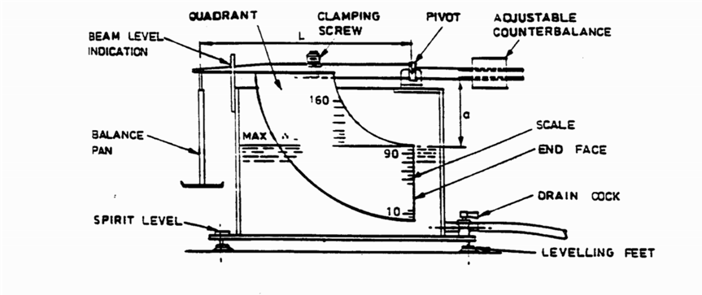

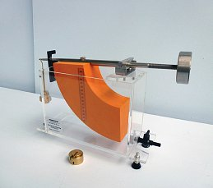

Observation tables:

|  |  |  |
| --- | --- | --- |
| **Mass(gm)** | **Hc(mm)** | **Hw(mm)** |
| **300** | **70** | **120** |
| **250** | **58** | **108** |
| **200** | **47.5** | **95** |
| **150** | **40.5** | **81** |
| **100** | **33** | **66** |
| **50** | **23** | **46** |
| **0** | **0** | **0** |

**calculations:**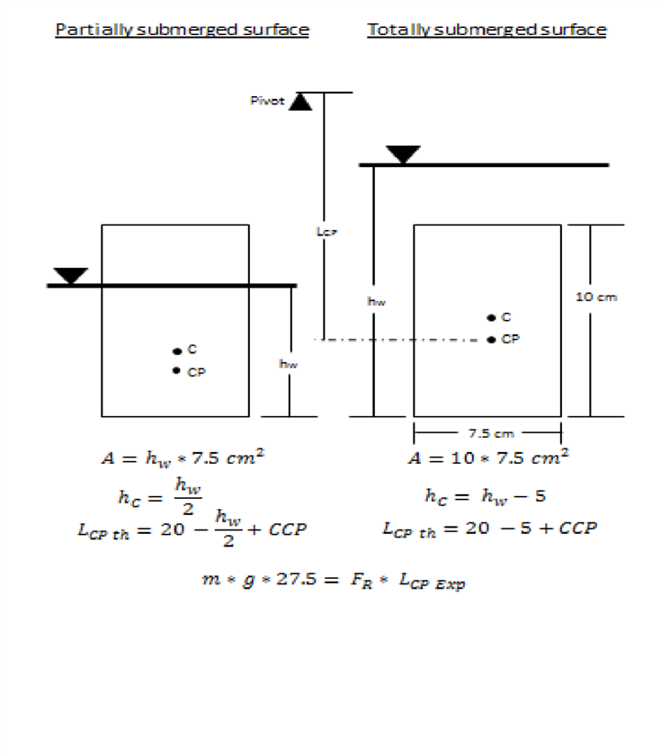

Determination of the position of the center of pressure Lcpexp experimentally:

𝐹𝑅 = 𝛾𝑤 ∗ ℎ𝑐 ∗ 𝐴

𝛾w = Specific weight of liquid.

hc = Vertical distance from the liquid surface to the centroid of the submerged area.

A = Area of the submerged surface (A = b x d).

Taking moments about the pivot:

Mg * L = FR *Lcpexp .

Where,

Lcpexp = Actual vertical distance from the pivot to point CP (center of pressure).

L = Perpendicular distance between the pivot and the point of action of the weights (C)

For totally submerged surface:

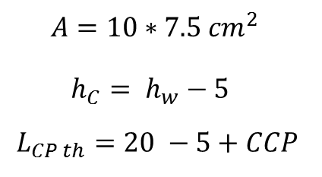

For partially submerged surface:

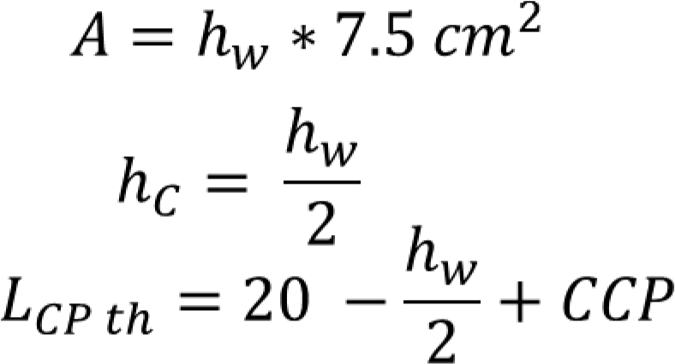

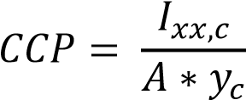

**Calculations for Table(1):**

|  |  |  |  |  |  |  |
| --- | --- | --- | --- | --- | --- | --- |
| **Mg ( N )** | **L ( m)** | **ɣL ( N/m3 )** | **hc ( m )** | **A ( m2 )** | **FR ( N )** | Lcpexp |
| 2.94 | 0.27 | 9800 | 0.07 | 0.0075 | 5.145 | 0.157 |
| 2.45 | 0.27 | 9800 | 0.058 | 0.0075 | 4.263 | 0.158 |
| 1.96 | 0.27 | 9800 | 0.0475 | 0.007125 | 3.3166 | 0.162 |
| 1.47 | 0.27 | 9800 | 0.0405 | 0.006075 | 2.4111 | 0.167 |
| 0.98 | 0.27 | 9800 | 0.033 | 0.00495 | 1.60083 | 0.168 |
| 0.49 | 0.27 | 9800 | 0.023 | 0.00345 | 0.77763 | 0.173 |
| 0 | 0 | 9800 | 0 | 0 | 0 | 0 |

Where;

yc = Vertical distance from the pivot to point C .

Ixx = Second moment of area about horizontal axis passing through point “c” and parallel to the liquid surface. b = Width of submerged surface. d = Length of submerged surface (Ixx = BH3/12 )

**Calculations for Table(2):**

|  |  |  |  |  |  |  |
| --- | --- | --- | --- | --- | --- | --- |
| **Hc ( m )** | **Ho (m)** | **Yc ( m )** | **A ( m2 )** | **Ixx** | *CCP* | **Lcpth (m)** |
| 0.07 | 0.08 | 0.27 | 0.0075 | 6.25*10-6 | 11.9*103 | 0.1617 |
| 0.058 | 0.09 | 0.27 | 0.0075 | 6.25*10-6 | 13.8*103 | 0.1638 |
| 0.0475 | 0.105 | 0.27 | 0.007125 | 5.358*10-6 | 15.8*103 | 0.1683 |
| 0.0405 | 0.118 | 0.159 | 0.006075 | 3.32*10-6 | 13.70*103 | 0.1727 |
| 0.033 | 0.134 | 0.167 | 0.00495 | 1.79*10-6 | 11.04*103 | 0.178 |
| 0.023 | 0.145 | 0.170 | 0.00345 | 0.608*10-6 | 11.7*103 | 0.1811 |

**Discussion & Conclusion**

**In summing the moments about the pivot of the apparatus, the buoyant force is neglected. As seen in the apparatus setup the fluid resides inside the torus. The presence of buoyancy comes from the air outside of the torus. Because the density of air is a mere fraction of that of the material of the torus and the fluid it contains , it can be neglected in the hydrostatic force calculations.**